
SCHOOL OF COMPUTING AND ENGINEERING SCIENCES (SCES)
BACHELORS OF SCIENCE IN COMPUTER NETWORK AND SECURITY
Assignment two
CNS 2206: PROBABILITY AND STATISTICS 1

DATE: 20/11/2025 Time: 21/20/2025

Instructions
1. This is group work assignment ( use the previous group)

QUESTION ONE (30 MARKS)
- Define an event in probability theory.

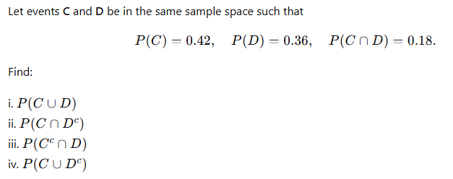
c) A factory produces resistors, and 12% are defective. In a random sample of n = 15 resistors, find the probability that:
i. Exactly 3 are defective
ii. No more than 2 are defective
iii. At least 1 is defective
iv. More than 4 are defective
d)
